SMT.TANUBHAI & DR. MANUBHAI TRIVEDI COLLEGE OF

INFORMATION SCIENCE (B.C.A)

AFFILIATED TO

VEER NARMAD SOUTH GUJARAT UNIVERSITY, SURAT

PROJECT REPORT

ON

“**E- Notes Management System**”



AS A PARTIAL REQUIREMENT FOR THE DEGREE

OF

BACHELOR OF COMPUTER APPLICATION

(B.C.A)

Academic Year: 2023 – 2024

INTERNAL GUIDE: SUBMITTED BY:

PROF. NIKISHA MITHAIWALA UMA CHAUDHARY

BENDRE PRATIKSHA

PRASAD ANJALI

PROJECT PROFILE

|  |  |
| --- | --- |
| Project Title: | E-Notes Management System |
| Project Definition: | The primary objective of the e-notes management system is to streamline and enhance the process of note-taking, storage, retrieval, and collaboration in a digital environment. |
| Duration: | 2 Months |
| Organization: | Smt. Tanuben & Dr. Manubhai Trivedi College of Information Science (B.C.A) |
| Developed For: | College |
| Front End: | HTML,CSS,BOOTSTRAP,JQUERY,AJAX |
| Back End: | PHP, MySql |
| Internal Guide: | Mrs. Nikisha Mithaiwala |
| Team Size: | 3 |
| Team Members: | Bendre Pratiksha  Uma Chaudhary  Prasad Anjali |

PERSONAL PROFILE

|  |  |
| --- | --- |
| Name: | Bendre Pratiksha |
| Contact No: | **9574831868** |
| Email Address: | **bendrepratiksha747@gmail.com** |
| Study center: | **Smt. Tanuben & Dr. Manubhai Trivedi College of Information Science** |
| Exam No: | **1893** |
| Academic Year: | **2023-2024** |

|  |  |
| --- | --- |
| Name: | Uma Chaudhary |
| Contact No: | **9316025773** |
| Email Address: | **chaudhary.uma10@gmail.com** |
| Study center: | **Smt. Tanuben & Dr. Manubhai Trivedi College of Information Science** |
| Exam No: | **1861** |
| Academic Year: | **2023-2024** |

|  |  |
| --- | --- |
| Name: | Prasad Anjali |
| Contact No: | **8140455917** |
| Email Address: | **anjalirprasad33gmail.com** |
| Study center: | **Smt. Tanuben & Dr. Manubhai Trivedi College of Information Science** |
| Exam No: | **1983** |
| Academic Year: | **2023-2024** |

ACKNOWLEDGEMENT

This has bee most practical and exciting part of our learning experience during 3 years of our degree, which would be an asset for us in our future career.

This was the professional step toward the high profile career in information technology. It was a great experience of exposing as well as learning of new thing in information technology as a whole at this level.

I take this opportunity to express my profound gratitude and deep regards to my guide **Mrs. Nikisha Mithaiwala** for her exemplary guidance and monitoring throughout the course of this thesis.

It is my pleasure to be indebted to various people, who directly or indirectly helped me in the project on “**E-Notes Management System**”.

Bendre Pratiksha

Uma Chaudhary

Prasad Anjali

**INDEX**

|  |  |  |
| --- | --- | --- |
| **Sr No.** | **Topic** | **Page No.** |
| **1.** | **Objective of the system** |  |
| **2.** | **Project Category** |  |
| **3.** | **Environment Used**  **3.1 Development Side**  **3.2 Client Side**  **3.3 Server Side** |  |
| **4.** | **Analysis Report**   * 1. **Overview of Current System**   2. **Drawback of current system**   3. **Requirement Specification**   4. **Proposed System**   5. **Advantages of proposed system**   6. **UML Diagram**   7. **Activity Diagrams**   8. **Table Structure with Proper Relationship** |  |
| **5.** | **Design Report**   * 1. **Security issues**   2. **Input Screen Layout**   3. **Output Screen Layout** |  |
| **6.** | **Testing Report**  **6.1 Testing Issues**  **6.2 Test case Design** |  |
| **7.** | **Limitation of the System** |  |
| **8.** | **Future Enhancement of the System** |  |
| **9.** | **Justification of MIS** |  |
| **10.** | **References** |  |

1.Objective Of System

The objective of an e-notes management system is to create an efficient and organized platform for the digital management of electronic notes. .

The primary objective of the e-notes management system is to streamline and enhance the process of note-taking, storage, retrieval, and collaboration in a digital environment.

This system aims to provide users with a user-friendly and centralized platform for creating, organizing, and accessing electronic notes, fostering increased productivity, collaboration, and knowledge-sharing within the organization or educational institution.

Key goals include improving information accessibility, ensuring data security, and facilitating seamless collaboration among users, ultimately optimizing the overall note management experience.

2.Project Category

Project Definition

* E-Notes Management System is based on Web Technology
* The E-Notes Management System is designed to provide a comprehensive digital solution for efficient note-taking, organization, and collaboration
* The primary goal is to transition from traditional paper-based note-taking methods to a streamlined electronic system, promoting accessibility, security, and collaboration.

3.Tools and Technology

Developer Site

Hardware Configuration

|  |  |
| --- | --- |
| Memory | 4.00 GB |
| Hard Disk Space | 100 GB |
| Microprocessor | 11th Gen Intel(R) Core(TM) i5-1155G7 @ 2.50GHz 2.50 GHz |

Software Configuration

|  |  |
| --- | --- |
| Operating System | Microsoft |
| Software | Visual Studio |
| Front-end | Html,css,bootstrap,jquery,ajax |
| Back-end | Php |
| Server | Apache Server |
| Database | Mysql |

Server Site

Hardware Configuration

|  |  |
| --- | --- |
| Memory | 4.00 GB |
| Hard Disk Space | 100GB |
| Microprocessor | 11th Gen Intel(R) Core(TM) i5-1155G7 @ 2.50GHz 2.50 GHz |

Software Configuration

|  |  |
| --- | --- |
| Operating System | Microsoft |
| Software | Visual Studio |
| Front-end | Html,css,bootstrap,jquery,ajax |
| Back-end | Php |
| Server | Apache Server |
| Database | Mysql |

Client Site

Client Side Configuration

Any web browser like internet Explorer,google chrome and Mozilla Firefox etc

**Front-End:**

* **HTML**- HTML stands for Hyper Text Markup Language. It is a markup language used to create web pages. HTML describes the structure of a web page by using tags and attributes. Tags are keywords enclosed in angle brackets (<>). Attributes provide additional information about the tag.
* **CSS** - CSS stands for Cascading Style Sheets. It is a style sheet language used to describe the presentation of web pages. CSS describes how HTML elements are to be displayed on screen, paper, or in other media. CSS is a powerful tool that can be used to create visually appealing and functional web pages. It is used in conjunction with HTML to create the look and feel of a web page.
* **BOOTSTRAP5 -** Bootstrap is a free and open-source front-end framework for developing websites and web applications. It is a collection of HTML, CSS, and javascript code that can be used to create responsive, mobile-first websites. Bootstrap is a powerful tool that can be used to create beautiful and functional websites.

**Back-End:**

* **PHP** -PHP is a general-purpose scripting language geared towards web development. It was originally created by Danish-Canadian programmer RasmusLerdorf in 1993 and released in 1995. The PHP reference implementation is now produced by the PHP Group.PHP is a server-side scripting language, which means that the code is executed on the server before being sent to the client. This makes PHP ideal for creating dynamic web pages that can interact with databases and other server-side resources.
* **MYSQL** - MySQL is an open-source relational database management system (RDBMS). It is one of the most popular databases in the world, and is used by a wide variety of websites and applications.MySQL is a server-based database, which means that it runs on a server and is accessed by clients. The server is responsible for storing and retrieving data from the database, while the clients are responsible for interacting with the data.MySQL uses Structured Query Language (SQL) to interact with the database. SQL is a standard language for querying and manipulating databases.MySQL is a powerful and versatile database that can be used for a wide variety of applications. It is a good choice for websites, applications, and other systems that need to store and manage large amounts of data.

4.Analysis Report

4.1 Existing System

* In the existing system the students need to manage notetaking can be viewed as recording information by hand on paper using pen and paper method(P&P)
* Make Time for Note taking Activities
* You can’t write down every word
* Pay Attention: it’s very easy to start daydreaming during lectures and miss an important point

4.2 Drawback of Existing System

* Physical notes are often confined to the location of their creation, making them difficult to access if lost or forgotten.
* Maintaining a systematic structure becomes more complex with increasing note volume.
* Physical notebooks can be lost, damaged, or destroyed, putting important information at risk.
* Sharing handwritten notes is less convenient than digital alternatives, making collaborative work more challenging.
* Manual note-taking struggles with integrating multimedia elements.
* Handwritten notes may be more susceptible to unauthorized access, loss, or theft.

**4.3 Requirement Specification**

User should be visit the website

User should be Login Website based on their role as a Faculty or Student

Faculty can upload Notes as pdf,doc,videos

Faculty can view Notes and Download

Faculty can upload Assignement

Faculty can view Assignment

Faculty can view Assignment Completion by Student

Faculty can Approve and Reject Assignement Completion

Faculty can have functionality like add,comment system

Faculty can view student based on their status like online or offline

Faculty should be logout the website

Student should be login

Student can view Notes and Download

Student can upload Assignment completion

Student view classmates based on their status like online or offline

Student can have functionality like view comment system

Student should be logout

Admin should be login

Admin should be manage everything like subject, Student, Faculty

**4.4 Proposed System**

The proposal for an **E-Notes Management System**. This system aims to streamline the organization and sharing of educational notes. Here are some key aspects of the proposed system:

* [The proposed system aims to overcome these limitations and provide an improved note-sharing experience](https://www.ijarsct.co.in/Paper10745.pdf)
* It provides a safe environment for sharing educational resources.
* [Efficient distribution of notes saves time for both teachers and students](https://www.slideshare.net/YashrajNigam/e-learning-project-report-yashraj-nigam)
* The primary goal is to create a user-friendly platform where recognized teachers can upload their notes.
* Students studying specific subjects can then easily access and download these notes.

**4.5 Roles of Current User**

* + **Guest User**

View Web application

Contant Page

* + **Faculty**

Can Login

Can Upload Notes(pdf,video,docs)

Can Allocate Assignments(pdf)

Can Allow or Reject Assignment

Can view Students By Search

Can View Student Status(online/offline)

* + **Student**

Can Login

View Notes

Upload completed Assignement(pdf)

Can View Classmates Status(online/offline)

* + **Admin**

Manage Faculty

Manage Student

View Contact

Manage Subject

**4.5 Advantages of Proposed System**

1. Accessibility Anytime, Anywhere:
   * Users can access their notes from any device with internet connectivity, providing flexibility and convenience.
2. Centralized Platform:
   * The system provides a centralized platform for note-taking, organization, and collaboration, reducing the need for multiple tools or platforms.
3. User-Friendly Interface:
   * The intuitive and user-friendly interface enhances the overall user experience, making it easy for users to create, edit, and organize their notes.
4. Real-Time Collaboration:
   * The system facilitates real-time collaboration, allowing users to work on shared notes simultaneously, fostering better teamwork and communication.
5. Notification System:
   * The notification system keeps users informed about updates, comments, or changes to shared notes, improving communication and collaboration.

4.6 **Data Flow Diagram :**

* + **Guest**

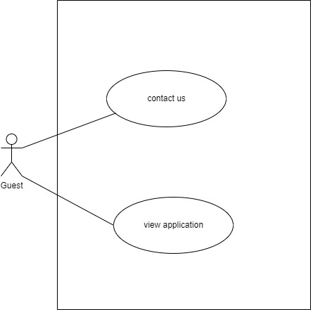

* + **Admin**

1. 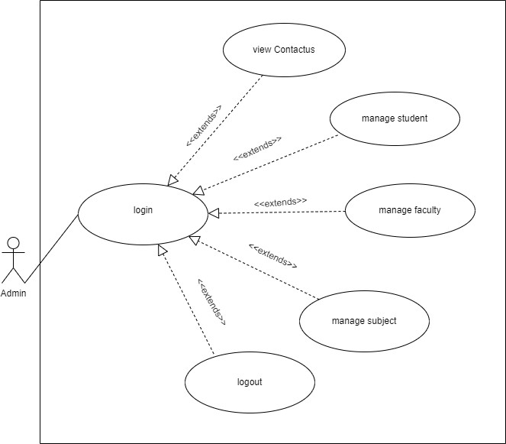
   * **Faculty**
2. 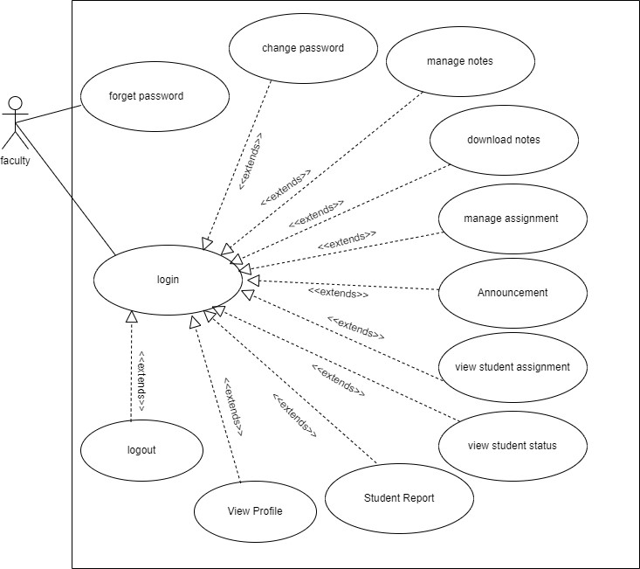
   * **Student**
3. 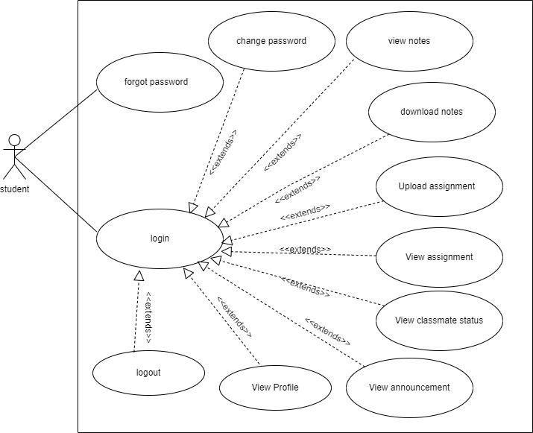

4.7 **Activity Diagram :**

* + **Login**

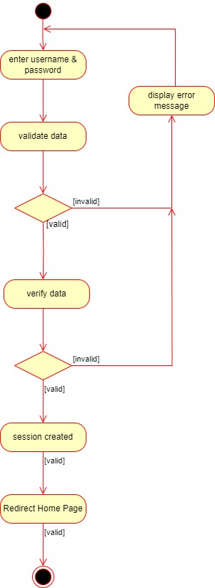

* + **Change Password**

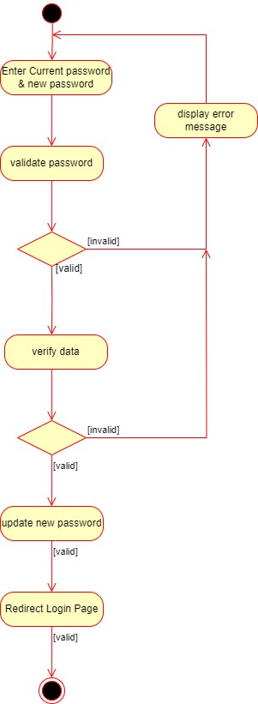

* + **Forget Password**

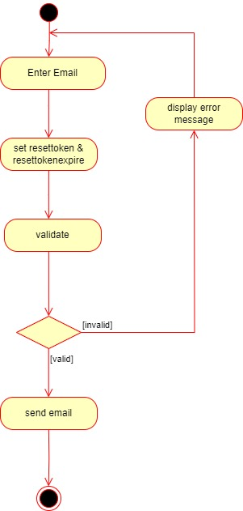

* + **Email Verify**



* + **Manage Data**

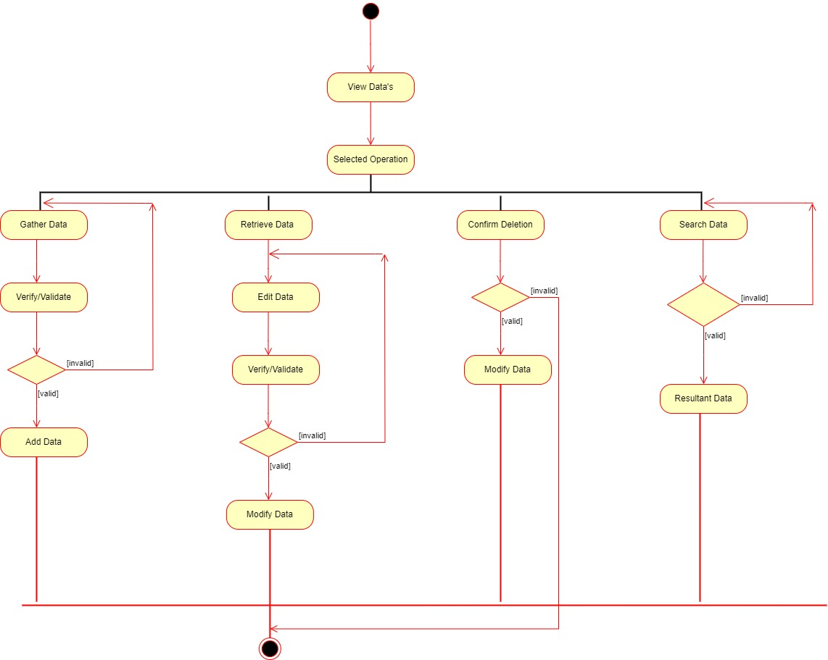

5.Table Structure

Table no: 1

Table Name: tbladmin

|  |  |  |  |  |  |
| --- | --- | --- | --- | --- | --- |
| Sr.No | Column Name | Data Type | Constrain | Allow Null | Default |
| 1. | id | Integer(100) | Primary Key | Yes | None |
| 2. | username | Varchar(100) | - | Yes | None |
| 3. | password | Varchar(100) | - | Yes | None |

Table No:2

Table Name: tblfaculty

|  |  |  |  |  |  |
| --- | --- | --- | --- | --- | --- |
| Sr.No | Column Name | Data Type | Constrain | Allow Null | Default |
| 1. | id | Integer(100) | Primary Key | No | None |
| 2. | regno | Vartchar(100) | - | No | None |
| 3. | fac_name | Vartchar(100) | - | No | None |
| 4. | fac_phone | Vartchar(100) | - | No | None |
| 5. | fac_email | Vartchar(100) | - | No | None |
| 6. | fac_address | Vartchar(100) | - | No | None |
| 7. | fac_username | Vartchar(100) | - | No | None |
| 8. | fac_password | Vartchar(100) | - | No | None |
| 9. | fac_gender | Vartchar(100) | - | No | None |
| 10. | fac_image | Vartchar(100) | - | No | None |
| 11. | resettoken | Vartchar(255) | - | Yes | Null |
| 12. | resettokenexpire | Date | - | Yes | NULL |
| 13. | register_date | timestamp | - | No | Current_timestamp |

Table No:3

Table Name:tblstudent

|  |  |  |  |  |  |
| --- | --- | --- | --- | --- | --- |
| Sr.No | Column Name | Data Type | Constrain | Allow Null | Default |
| 1. | id | Integer(100) | Primary Key | No | None |
| 2. | regno | Varchar(100) | - | No | None |
| 3. | stud_name | Varchar(100) | - | No | None |
| 4. | stud_phone | Varchar(100) | - | No | None |
| 5. | stud_email | Varchar(100) | - | No | None |
| 6. | stud_address | Varchar(100) | - | No | None |
| 7. | stud_username | Varchar(100) | - | No | None |
| 8. | stud_password | Varchar(100) | - | No | None |
| 9. | stud_gender | Varchar(100) | - | No | None |
| 10. | stud_image | Varchar(100) | - | No | None |
| 11. | resettoken | Varchar(255) | - | Yes | NULL |
| 12. | resettokenexpire | date | - | Yes | NULL |
| 13. | register_date | timestamp | - | No | Current_timestamp() |

Table No:4

TableName: tblsubject

|  |  |  |  |  |  |
| --- | --- | --- | --- | --- | --- |
| Sr.No | Column Name | Data Type | Constrain | Allow Null | Default |
| 1. | id | Integer(100) | Primary Key | No | None |
| 2. | subject_code | Integer(11) | - | No | None |
| 3. | subject_name | Varchar(255) | - | No | None |
| 4. | short_name | Varchar(255) | - | No | None |
| 5. | allocated_faculty | Varchar(255) | - | No | None |

Table no:5

Table name:tblassignment

|  |  |  |  |  |  |
| --- | --- | --- | --- | --- | --- |
| Sr.No | Column Name | Data Type | Constrain | Allow Null | Default |
| 1. | Srno | Integer(100) | Primary Key | No | None |
| 2. | UploadedBy | Varchar(255) | - | No | None |
| 3. | UploadedOn | Timestamp | - | No | Current_timestamp |
| 4. | Subject | Varchar(255) | - | No | None |
| 5. | Assignment | Varchar(255) | - | No | None |
| 6. | Start_Date | Date | - | No | None |
| 7. | Start_End | Date | - | No | None |
| 8. | Type | Varchar(255) | - | No | None |
| 9. | Description | Varchar(255) | - | No | None |
| 10. | Title | Varchar(255) | - | yes | None |

Table no:7

Table name:tblevent

|  |  |  |  |  |  |
| --- | --- | --- | --- | --- | --- |
| **Sr.No** | **Column Name** | **Data Type** | **Constrain** | **Allow Null** | **Default** |
| **1.** | event_id | Integer (11) | Primary Key | No | None |
| **2.** | event_name | Varchar (255) | - | Yes | Null |
| **3.** | event_start_date | Date | - | Yes | Null |
| **4.** | event_end_date | Date | - | Yes | Null |

Table no:6

Table name:tblnotes

|  |  |  |  |  |  |
| --- | --- | --- | --- | --- | --- |
| **Sr.No** | **Column Name** | **Data Type** | **Constrain** | **Allow Null** | **Default** |
| **1.** | Srno | Integer (100) | Primary Key | No | None |
| **2.** | UploadedBy | Varchar (255) | - | No | None |
| **3.** | UploadedOn | Date | - | No | None |
| **4.** | Subject | Varchar (255) | - | No | None |
| **5.** | Notes | Varchar (255) | - | No | None |
| **6.** | Type | Varchar (255) | - | No | None |
| **7.** | Description | Varchar (255) | - | No | None |
| **8.** | Title | Varchar (255) | - | Yes | Null |

Table no:8

Table name:comments

|  |  |  |  |  |  |
| --- | --- | --- | --- | --- | --- |
| **Sr.No** | **Column Name** | **Data Type** | **Constrain** | **Allow Null** | **Default** |
| **1.** | id | Integer (11) | Primary Key | No | None |
| **2.** | assign_id | Integer (11) | - | No | None |
| **3.** | comment_id | Integer (11) | - | No | None |
| **4.** | name | Varchar (100) | - | Yes | Null |
| **5.** | description | Text | - | No | None |
| **6.** | register_date | timestamp | - | No | Current_timestamp() |

Table no:9

Table name:comments_notes

|  |  |  |  |  |  |
| --- | --- | --- | --- | --- | --- |
| **Sr.No** | **Column Name** | **Data Type** | **Constrain** | **Allow Null** | **Default** |
| **1.** | id | Integer (11) | Primary Key | No | None |
| **2.** | notes_id | Integer (11) | - | No | None |
| **3.** | comment_id | Integer (11) | - | No | None |
| **4.** | name | Varchar (100) | - | Yes | Null |
| **5.** | description | Text | - | No | None |
| **6.** | register_date | timestamp | - | No | Current_timestamp() |

Table no:10

Table name:tblcontact

|  |  |  |  |  |  |
| --- | --- | --- | --- | --- | --- |
| **Sr.No** | **Column Name** | **Data Type** | **Constrain** | **Allow Null** | **Default** |
| **1.** | id | Integer (100) | Primary Key | No | None |
| **2.** | first_name | Varchar (255) | - | No | None |
| **3.** | last_name | Varchar (255) | - | No | None |
| **4.** | email | Varchar (255) | - | No | Null |
| **5.** | message | Varchar (255) | - | No | None |
| **6.** | register_date | timestamp | - | Yes | Current_timestamp() |

Table no:11

Table name:tbluploadassign

|  |  |  |  |  |  |
| --- | --- | --- | --- | --- | --- |
| **Sr.No** | **Column Name** | **Data Type** | **Constrain** | **Allow Null** | **Default** |
| **1.** | id | Integer (100) | Primary Key | No | None |
| **2.** | uploadedby_stud | Varchar (255) | - | No | None |
| **3.** | uploaded_assign | Varchar (255) | - | No | current_timestamp() |
| **4.** | uploadedon | timestamp | - | No | None |
| **5.** | title | Varchar (255) | - | No | None |
| **6.** | description | Varchar (255) | - | No | None |
| **7.** | subject | Varchar (255) | - | No | None |
| **8.** | date | Date | - | Yes | Null |
| **9.** | status | Varchar (255) | - | No | pending |

5.Design Report

Security Issue:

* User authentication is performed so that no authorized user can access the system.
* Email ID and Password are authorized from the database.
* System operations are performed as per the type of users using the systems.
* User cannot change his/her password without entering the old password.
* Session is maintained is for user.
* Only Logged in user can access notes.
* Websites uses encryption and decryption method to store user password.

Input Screen Layout:

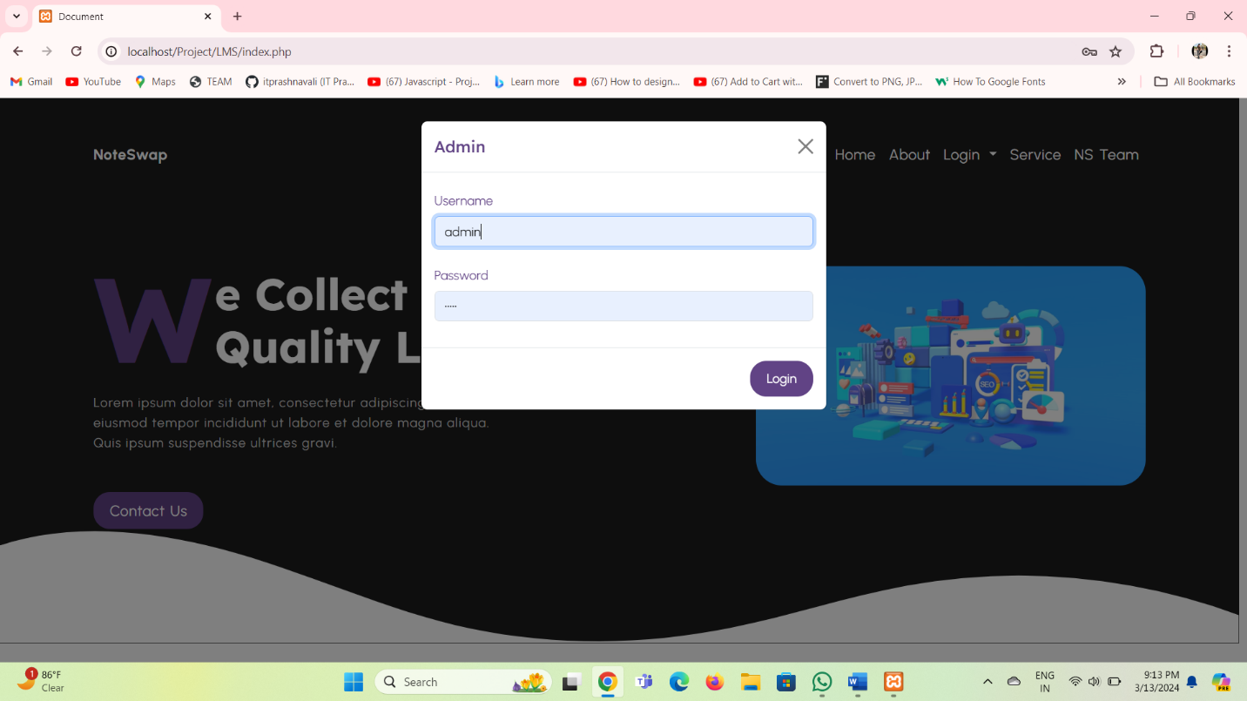

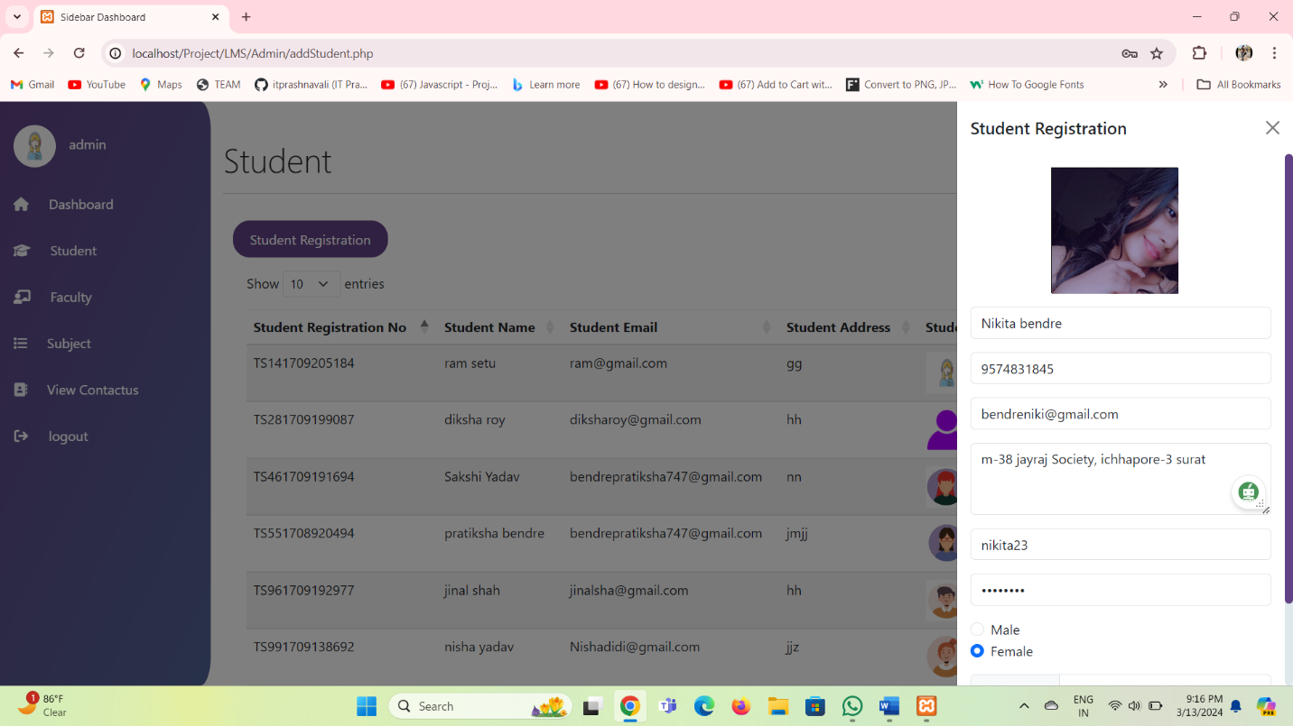

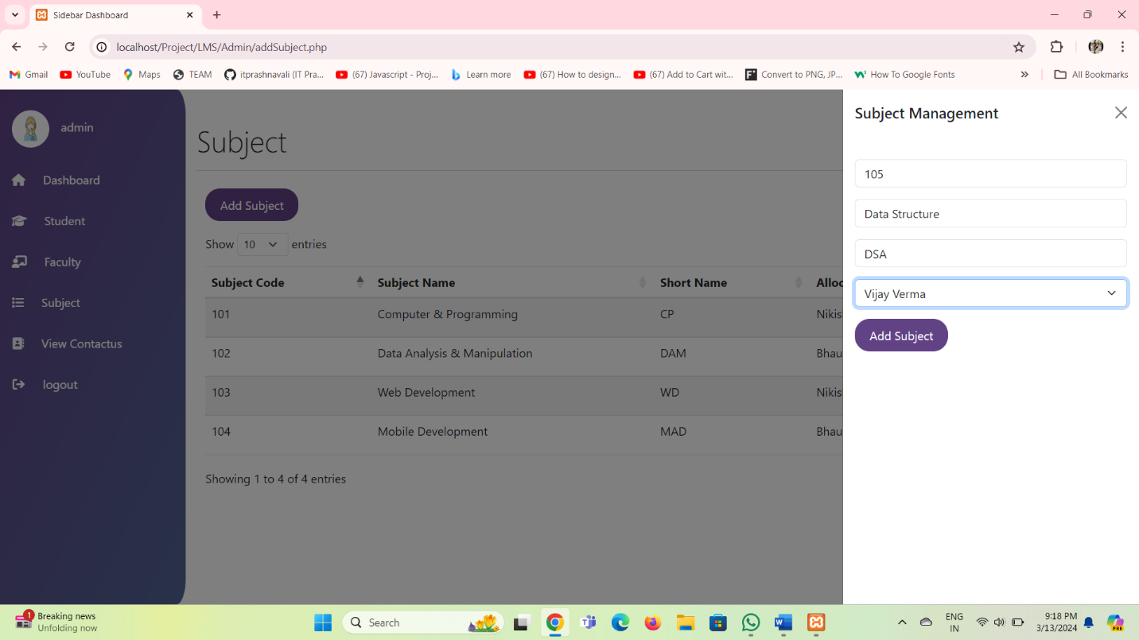

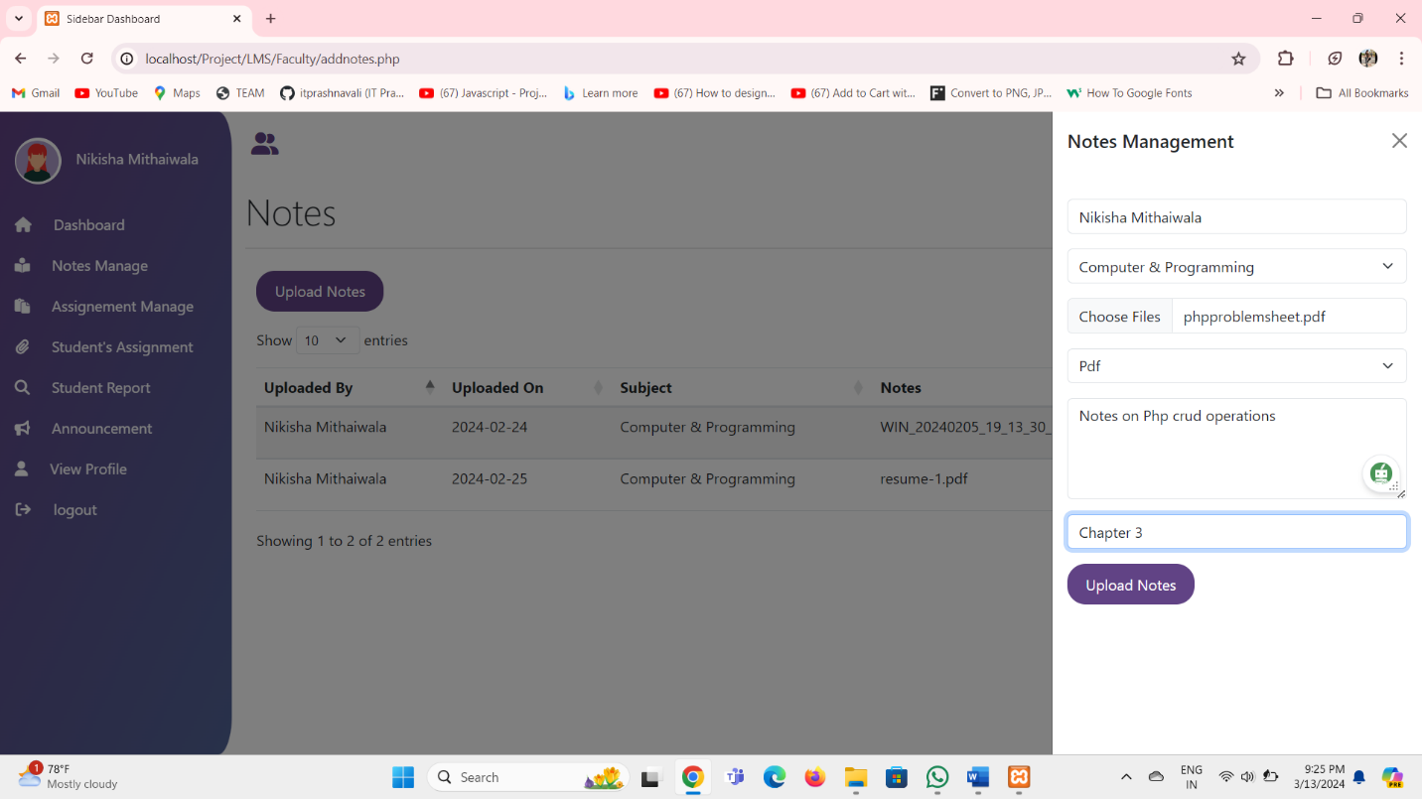

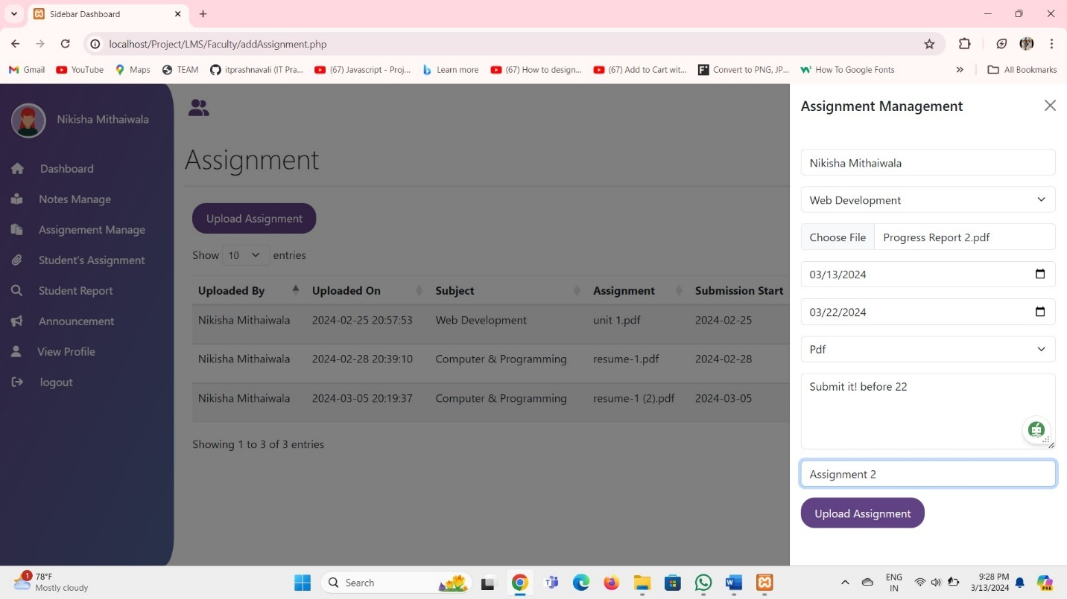

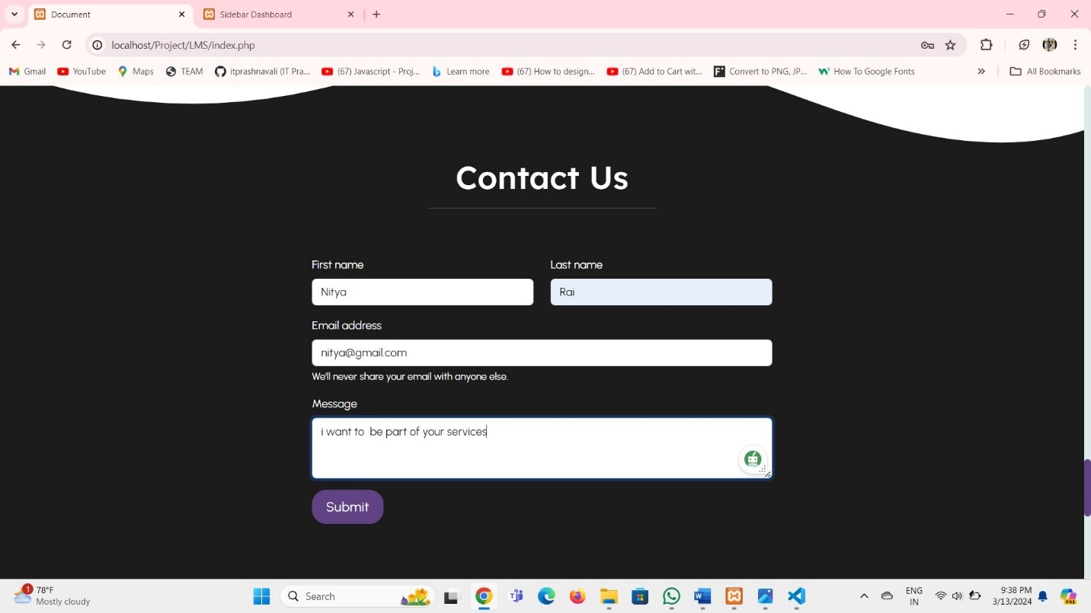

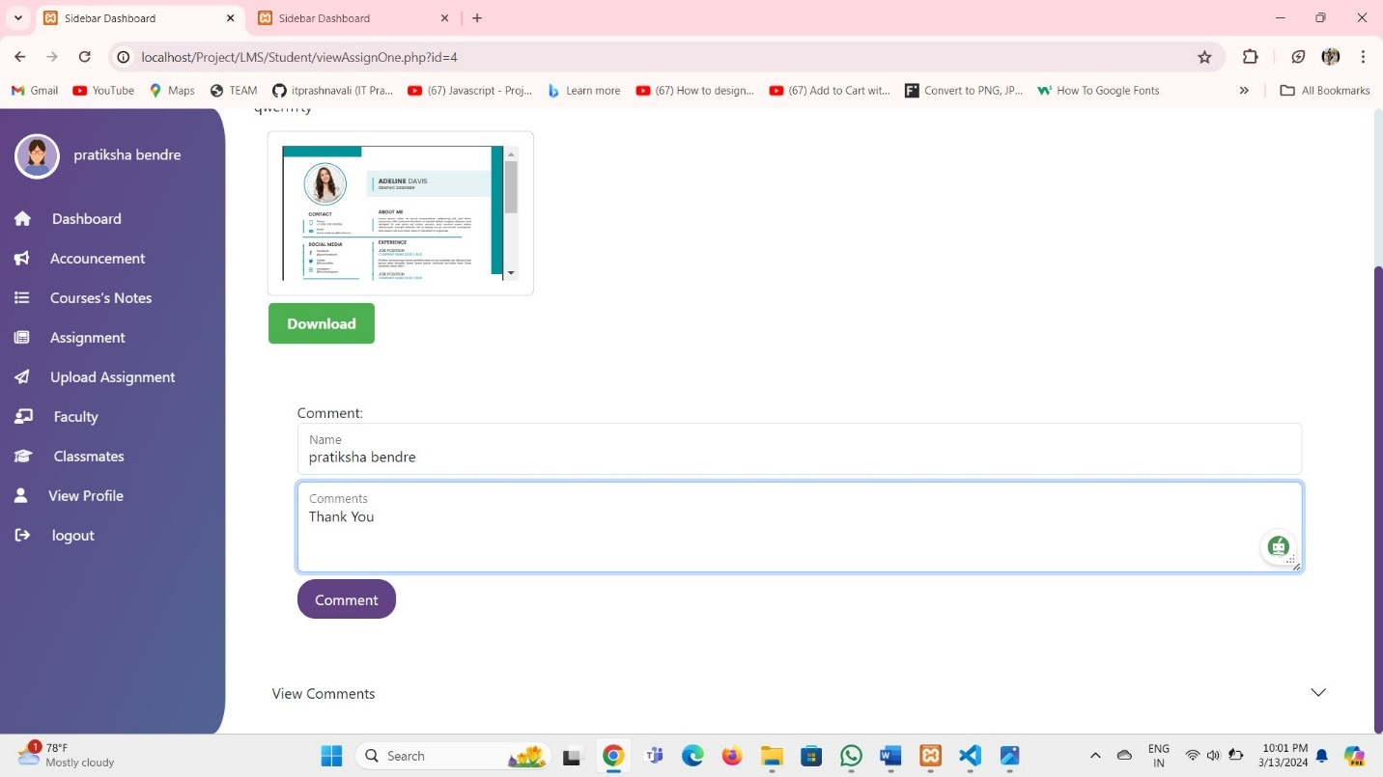

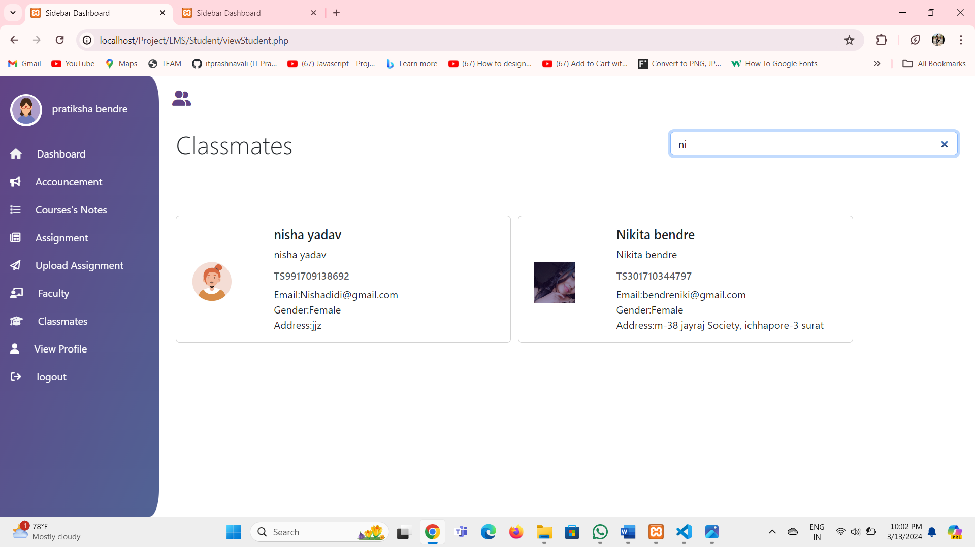

Output Screen Layout:

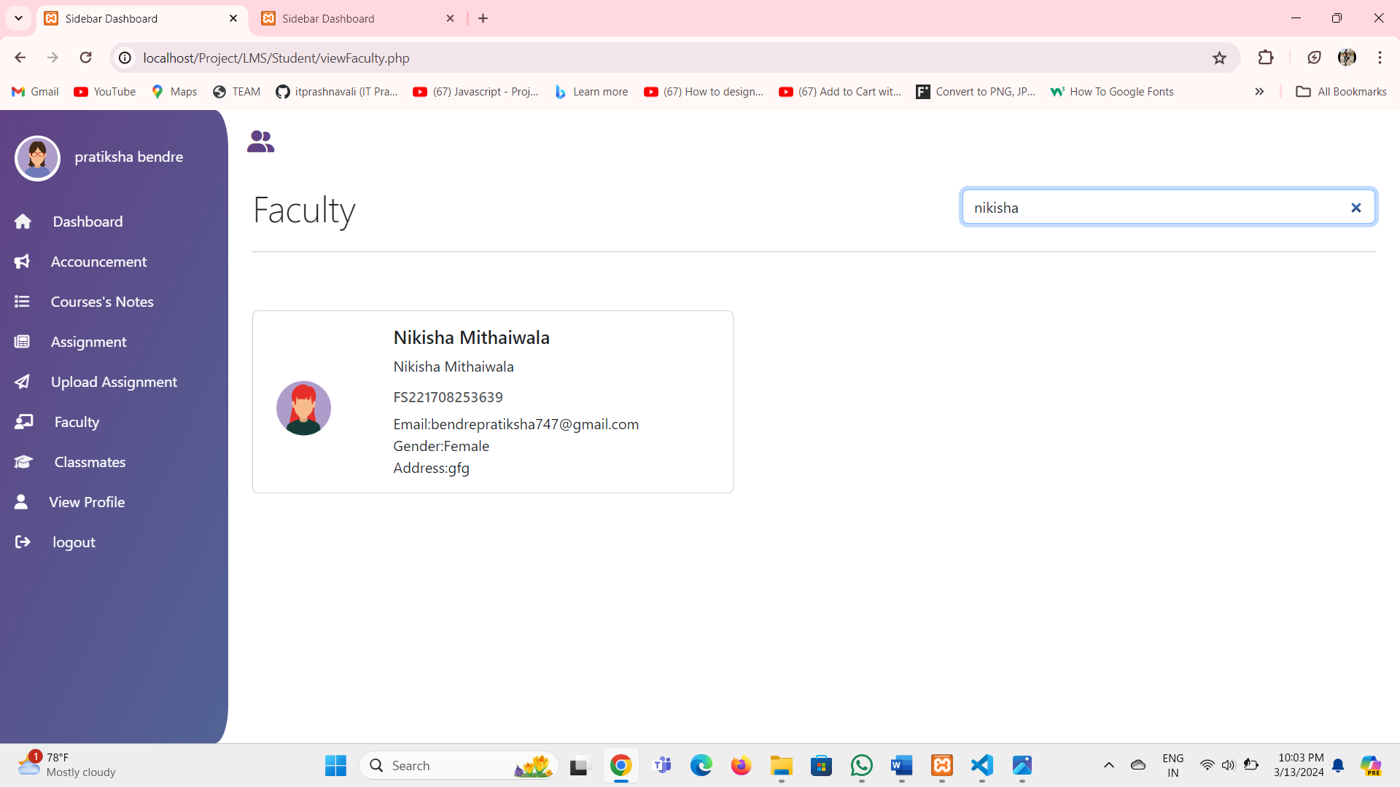

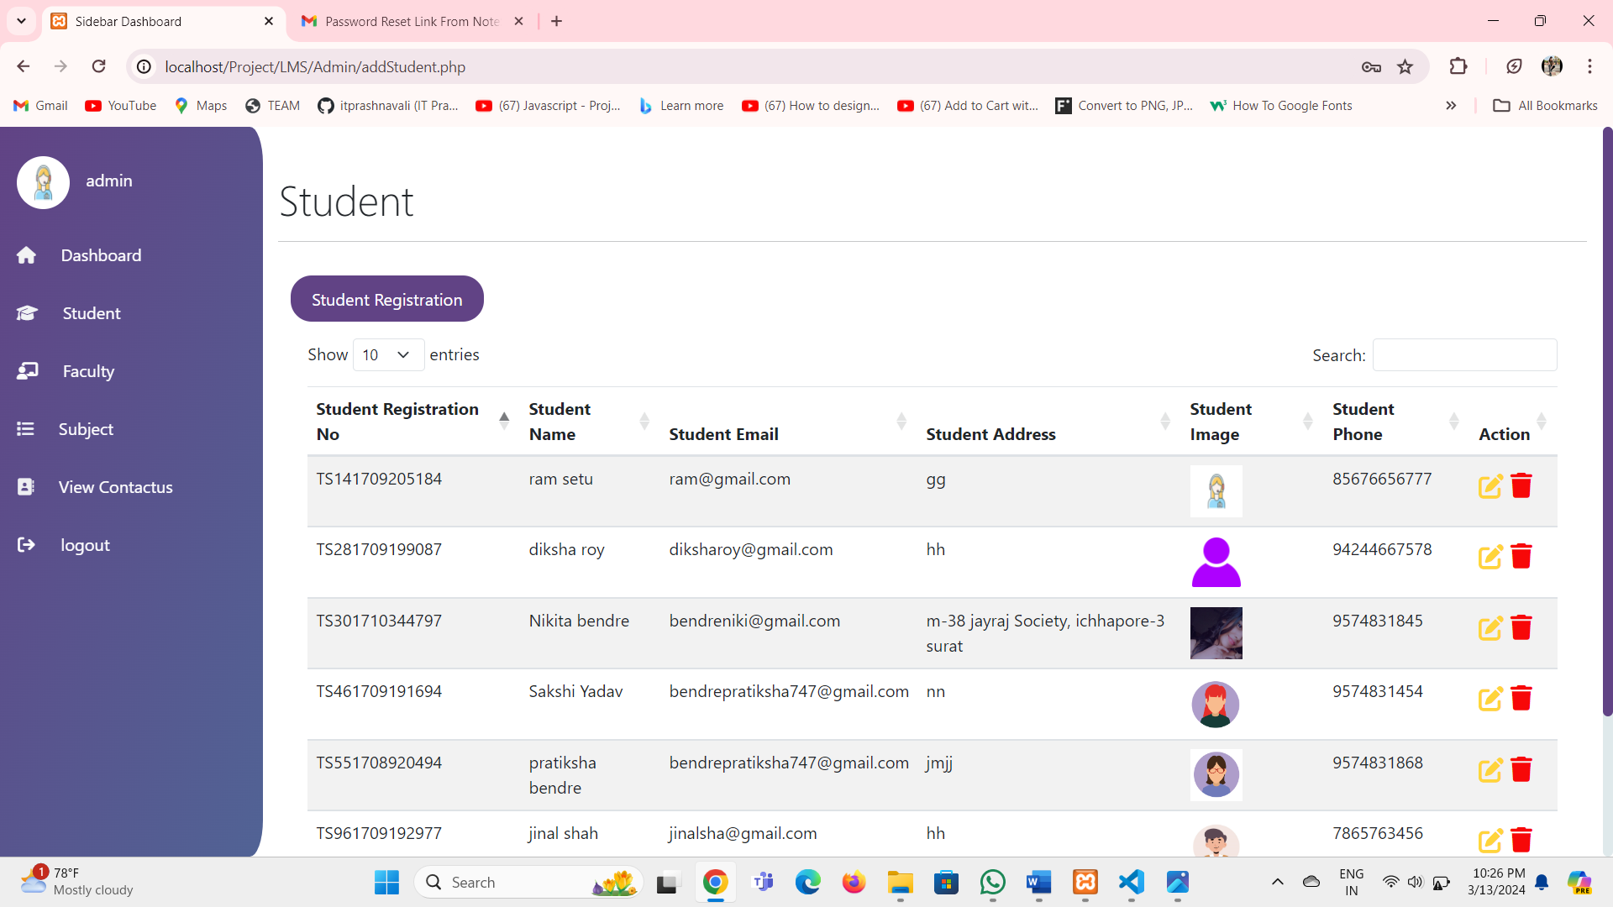

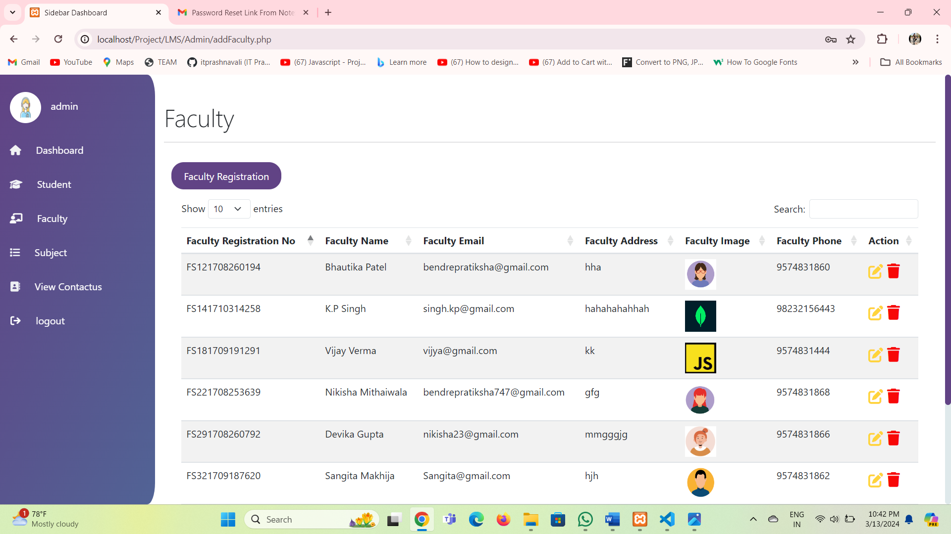

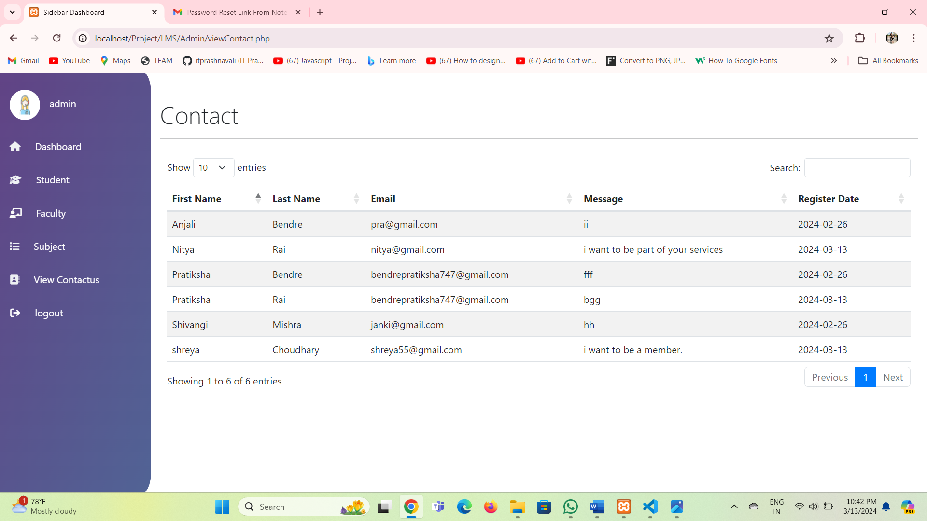

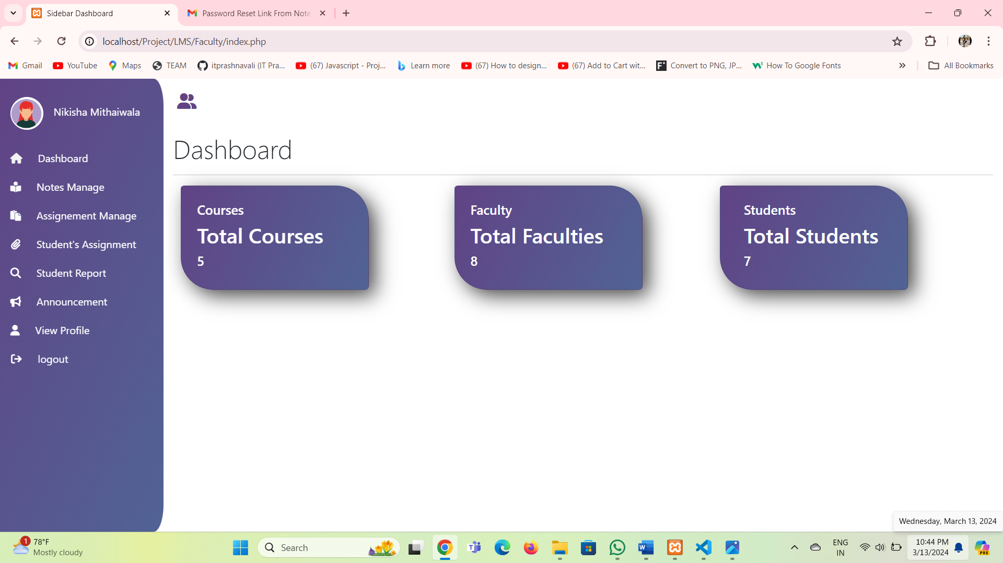

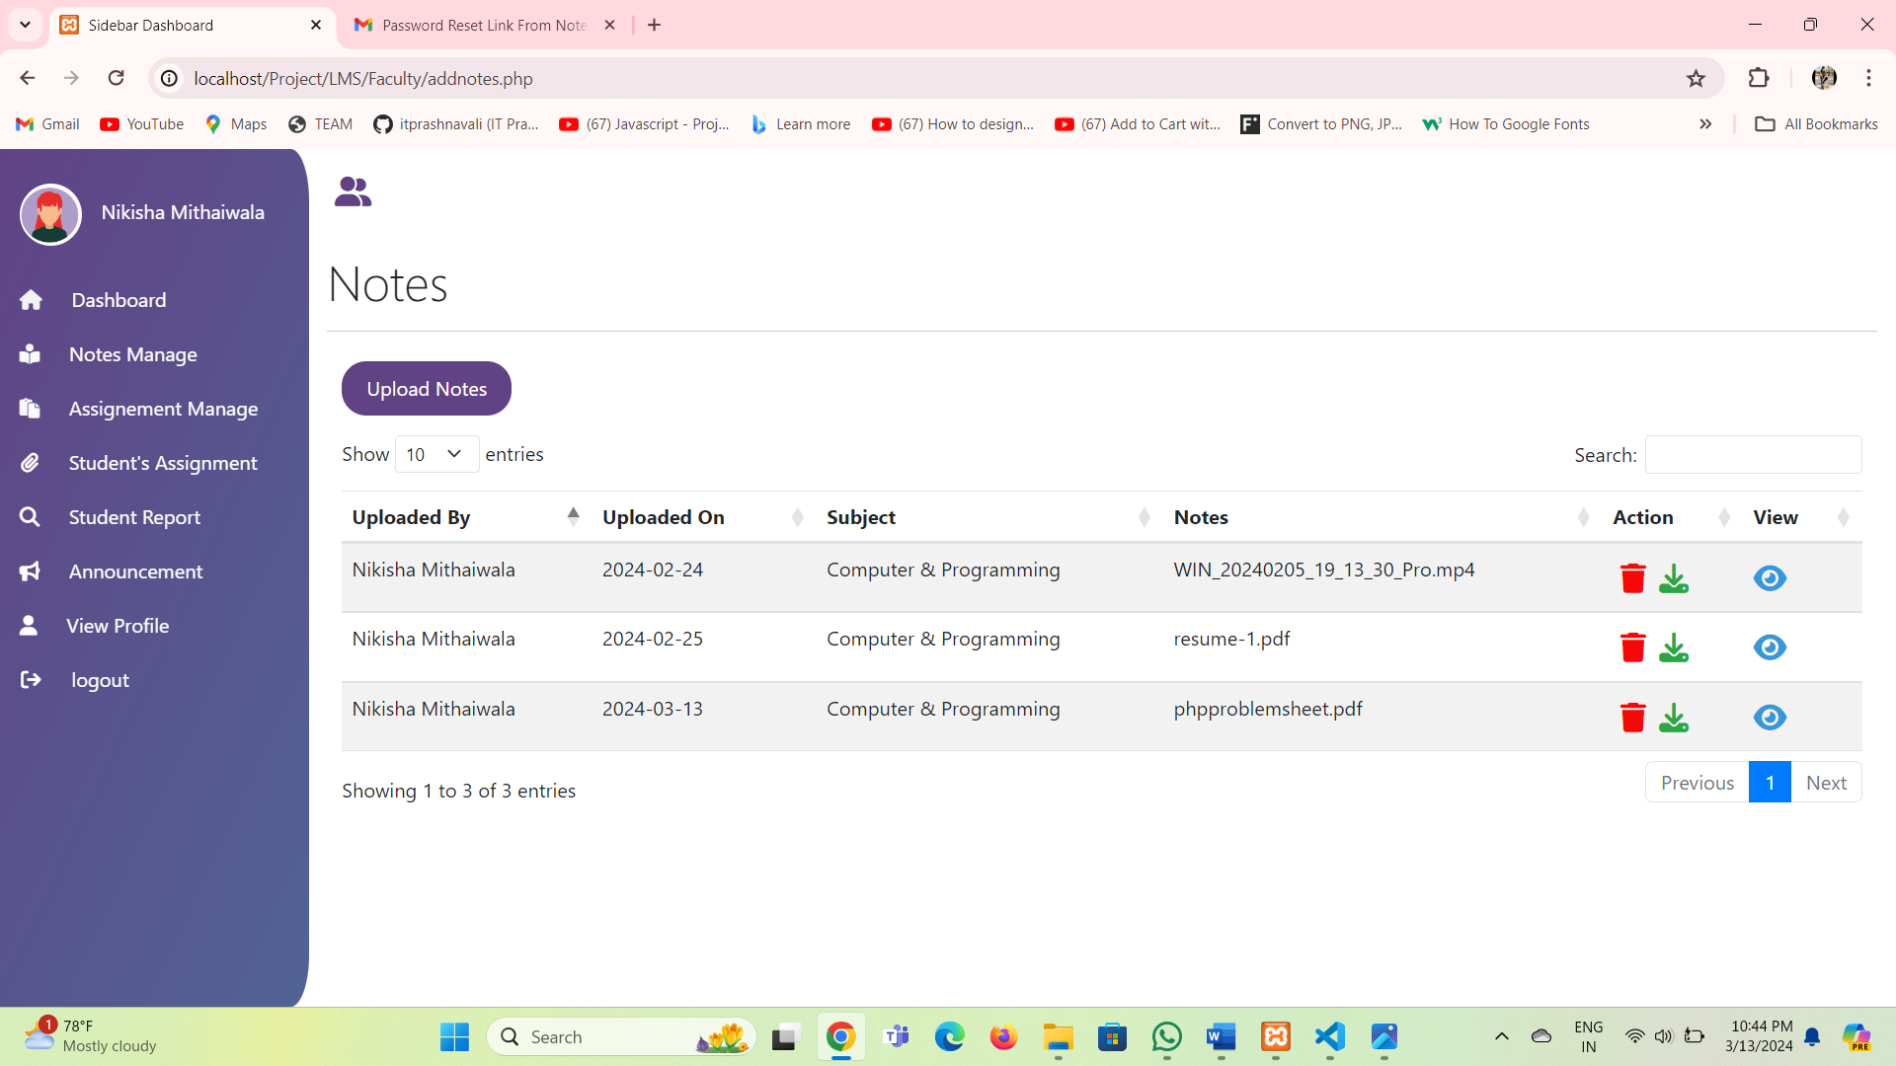

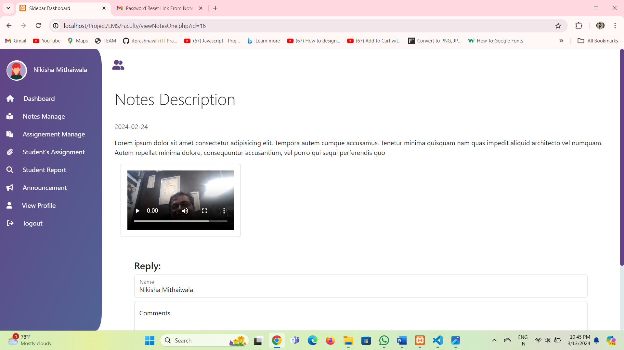

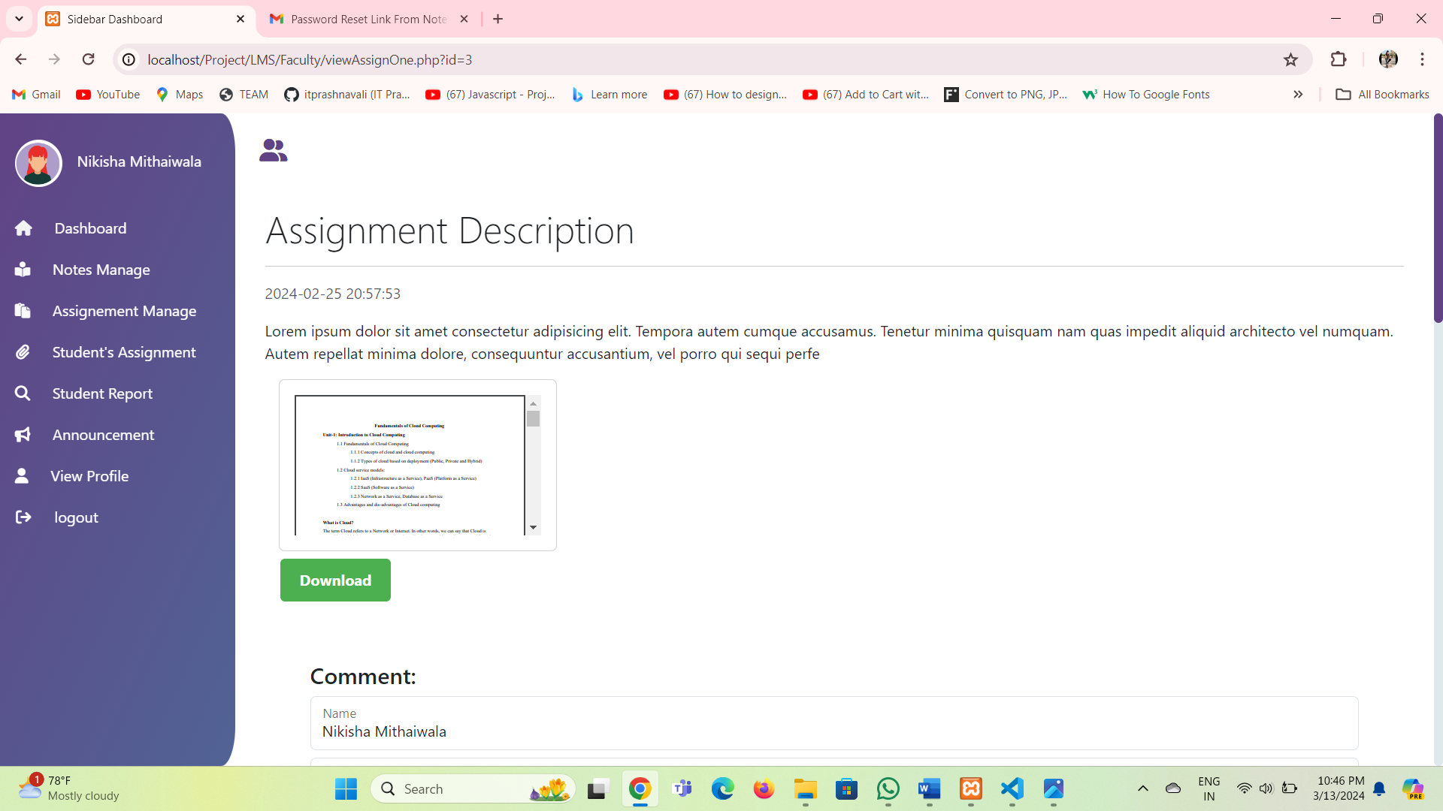

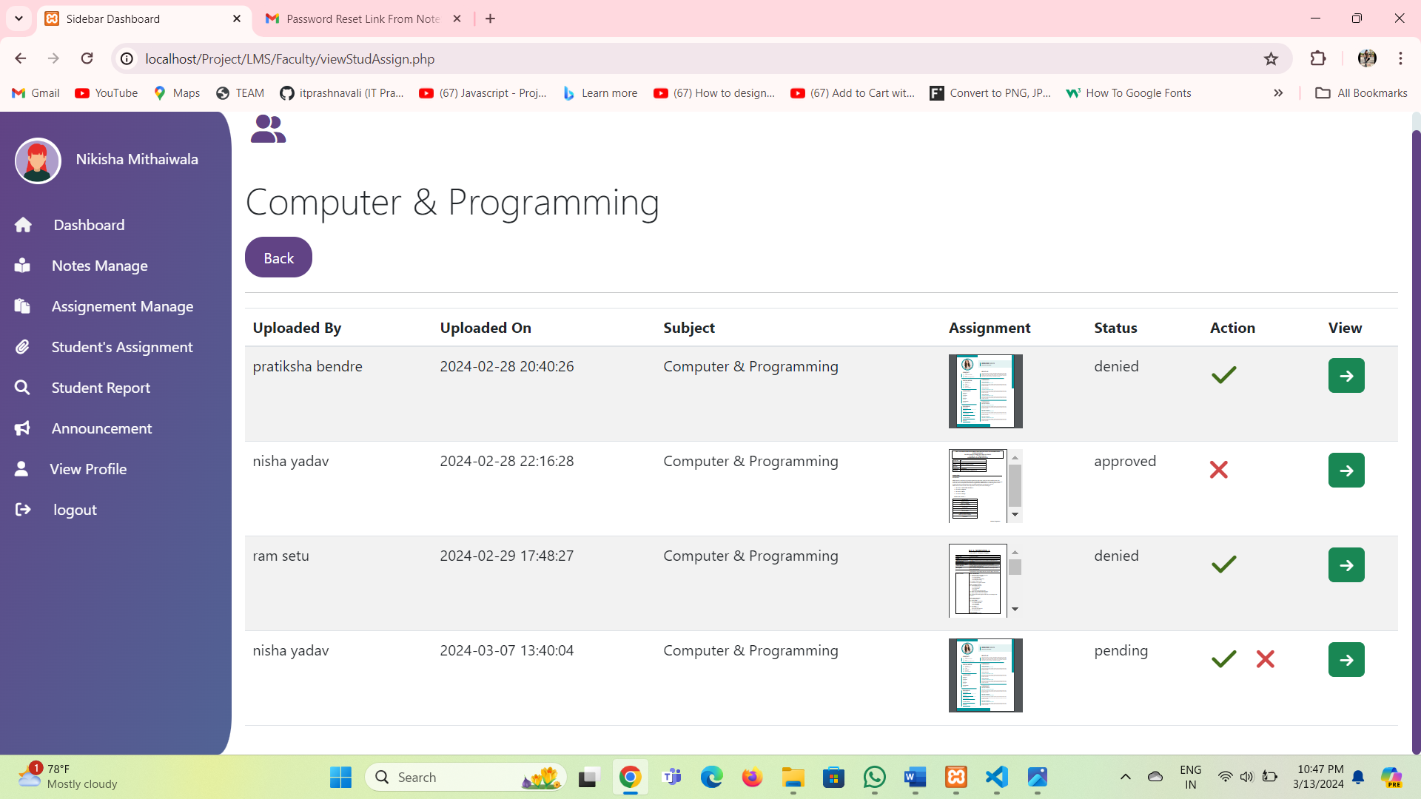

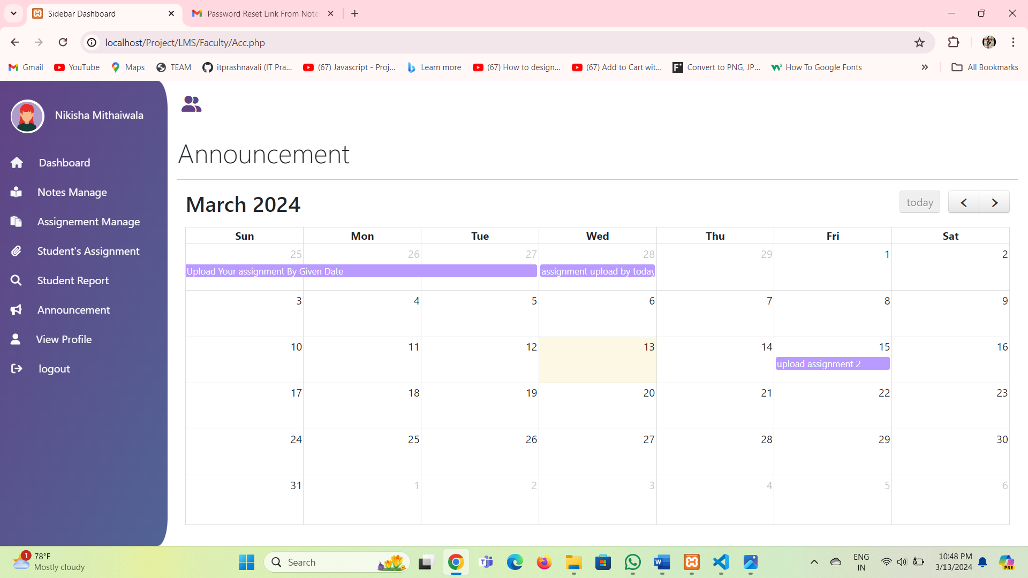

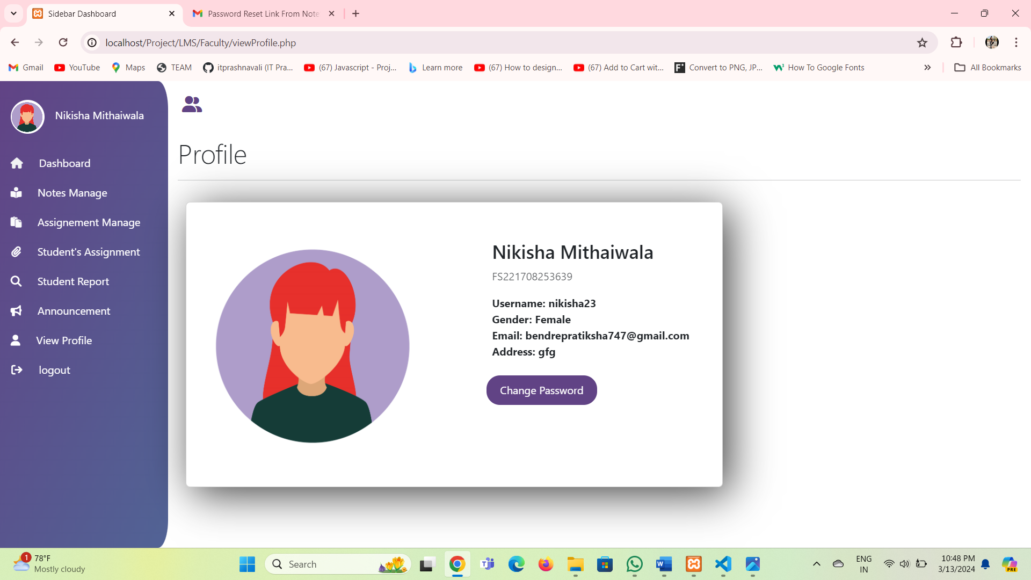

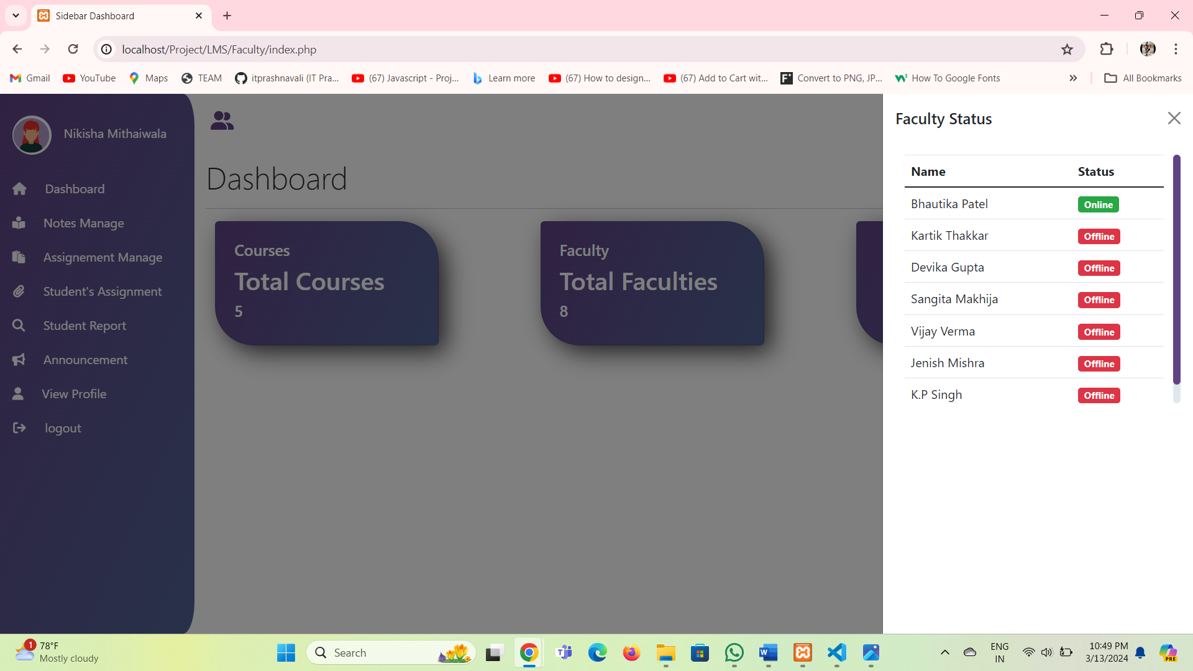

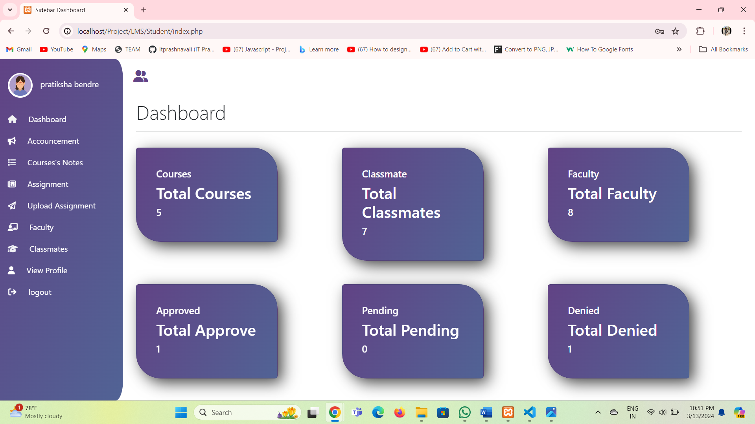

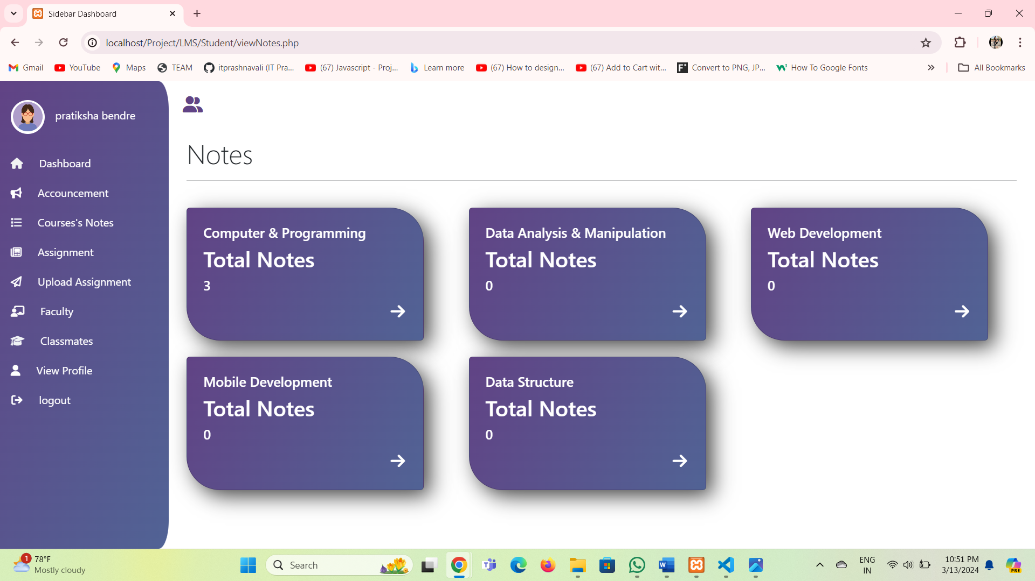

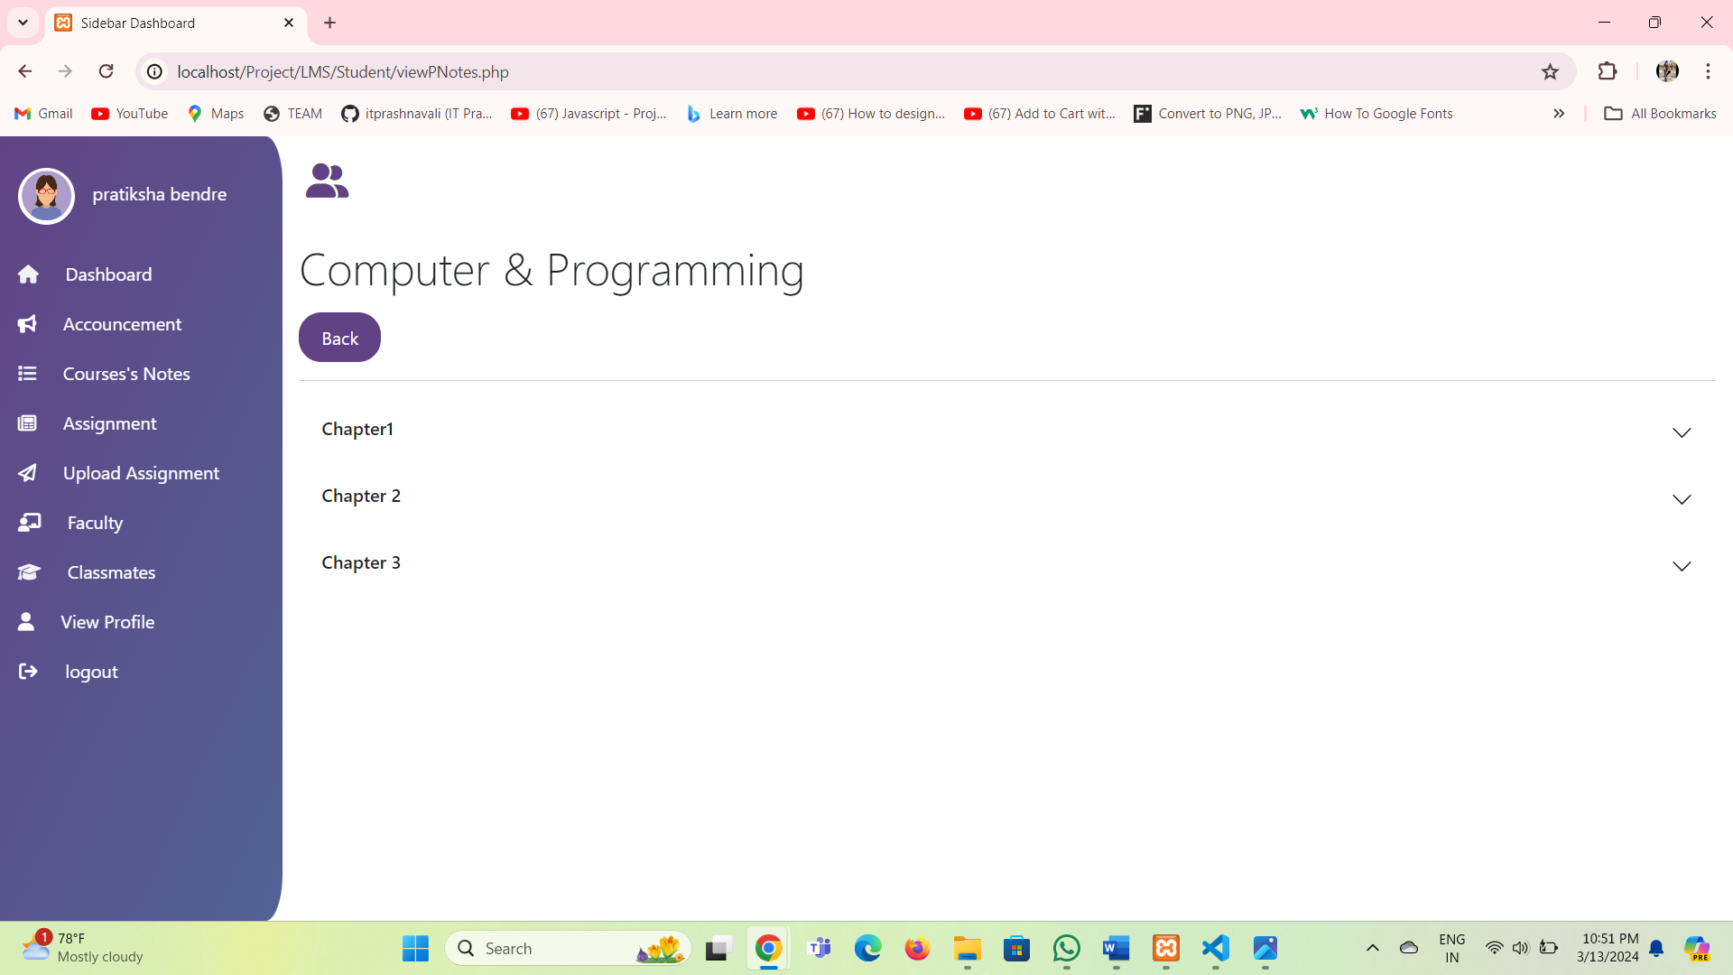

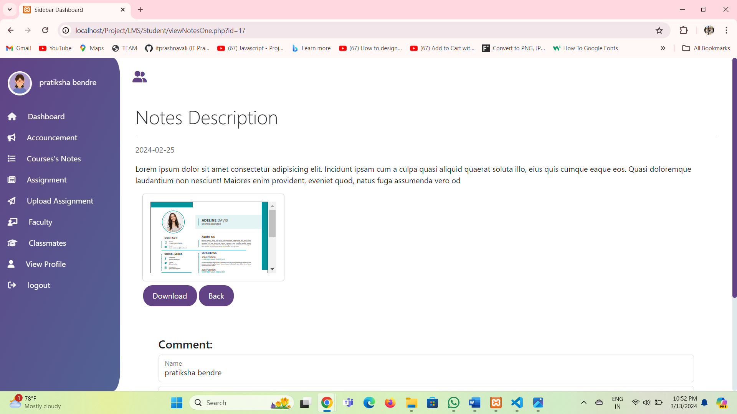

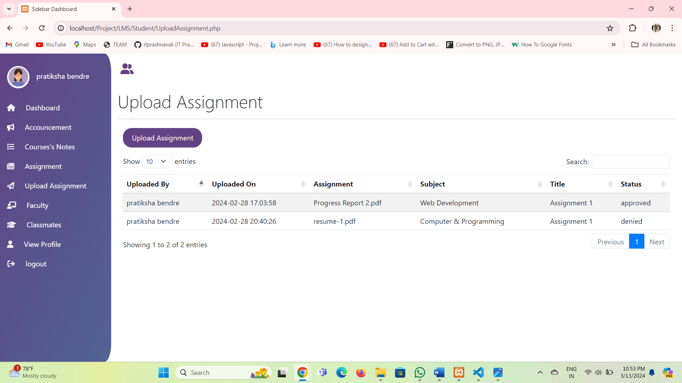

**6.Testing Report**

**6.1 Testing issues**

testing is the process of evaluating a software program to find bugs and ensure it functions as expected. It involves checking different aspects of the software, including functionality, performance, usability, and security. Testers typically follow a set of procedures to identify errors and areas for improvement.

Testing Includes the white box and black box testing techniques.

## **Types of Software testing**

1. **Manual Testing**

The purpose of The purpose of manual testing is to uncover any defects in the software product by manually inspecting individual functions. The software testing scenario is highly iterative, where test functions are repeated until a desired level of accuracy is achieved. This process can be iterative or granular, where the desired debugging level works only when an actual program is running. A manual test can be as simple as copying and pasting the code from one place to another or as complex as writing a test case and running it hundreds of times.

#### ****a) Black box testing****

In black box testing, engineers don’t see the black box and only see the inputs, outputs, and hardware components that support them.

For example-When, a user clicks on a registration page; then, black box testing verifies if that registration page is opening and all the features on that page are working or not.

#### ****b) White box testing****

White-box testing is a technique that allows testers to view and access an application’s internal structure or code. Using this technique, you can easily find loopholes in your application’s design and flaws in your business logic. In white box testing, elements of a software system, such as functions, functions, steps, or methods, are visible to the end user.  
 For example, If there is a registration page in a website then the tester is concerned about understanding the code for the registration page. He is concerned about which functions and classes are being called and when.

#### ****c) Grey box testing****

Grey box testing, as the name suggests, is a combination of white-box and black- box testing. Testers don’t have complete knowledge of the internal structure or code of the application.

The testing is done based on high-level database diagrams and data flow diagrams.  
 The purpose of grey box testing is to find and isolate bugs resulting from improper code structure or application usage.  
 This process often identifies context-specific errors related to web systems. Expand your testing by focusing on all layers of a complex system.

1. **Automation Testing**

On the other hand, automated tests are run by a machine running a previously written test script. These tests vary in complexity, from checking one of the methods in a class to verifying the performance of a complex set of actions in the user interface. Although much more robust and reliable than manual tests, the quality of automated tests depends on how well the test scripts are written.So expertise is required to write the test scripts.

### 1. Unit Testing

Unit testing is software testing run against a single unit or component to test modifications. Developers typically perform unit tests during the development stage of an application. Each test unit can be viewed as a method, function, procedure, or object. Developers often use NUnit, Xunit, JUnit, and other test automation tools for running tests.

For example-If, an e-commerce website is developed. Its different modules/units like login page, registration page, adding/removing items in cart, payment page, etc., are checked by developers one by one.

### 2. Integration testing

Integration testing is software testing that logically groups two or more modules of an application and tests them as a whole. This type of testing focuses on finding faults in interfaces, communications, and data flow between modules.

For example- A user purchases items on an e-commerce website. Users can see item and payment information, but item details and payment processing are two different systems. Integration testing should be performed during the integration of the e-commerce website with the payment processing system. It is of two types:

**a) Incremental testing**

This testing involves testing each module individually during the unit testing phase and then integrating and testing the modules incrementally to ensure that the interfaces and interactions between modules are smooth.

#### b) Non incremental testing

The non-incremental approach is also known as “Big-Bang” testing. Non- incremental integration testing combines all the modules at a shot and tests the data flow between these modules. It won’t be easy to identify which is the parent module and which is the child module.

**6.2 Test Cases**

* Login

|  |  |  |  |
| --- | --- | --- | --- |
| Test Field | Test data | Valid/Invalid | Test result |
| Username | Null | Invalid | Please enter username |
|  | 123 | Invalid | Please enter valid username |
|  | ABC | valid | - |
| Password | Null | Invalid | Please enter password |
|  | 323 | Invalid | Please enter alphanumeric |
|  | 123Abc | valid | - |

* Change password

|  |  |  |  |
| --- | --- | --- | --- |
| Test Field | Test data | Valid/Invalid | Test result |
| Current Password | Null | Invalid | Please enter username |
|  | 123 | Invalid | Please enter alphanumeric |
|  | 123ABC | valid | - |
| New Password | Null | Invalid | Please enter password |
|  | 323 | Invalid | Please enter alphanumeric |
|  | Abc111 | valid | - |

* Forget password

|  |  |  |  |
| --- | --- | --- | --- |
| Test Field | Test data | Valid/Invalid | Test result |
| New Password | Null | Invalid | Please enter username |
|  | 321 | Invalid | Please enter alphanumeric |
|  | Abc112 | valid | - |
| confirm Password | Null | Invalid | Please enter password |
|  | 323 | Invalid | Please enter alphanumeric |
|  | Abc112 | valid | - |

7.Limitation of System

* Improvement in GUI and more user friendly interface.
* Limited Interaction and Discussion.
* It is not a single page application.
* It can not share notes with other applications.

**8.Future Enhancement**

* One can upgrade the performance of report(including more graphical reports);
* Backup and Restore facilities can also be included
* Doubt session can be added for students by faculty.
* Group session can be added for students.
* Chat bot can be included.
* Live video chatr for student and faculty.
* Collabrative Sticky Notes.

9.Justification of MIS

* MIS is general terms for the computer systems in a organization that assists the administrator of the organization in management oriental task and problem specific task and problem solving.
* Systems produced various details that help the administration to keep track of all security issues in an undergoing to an organization which are used in any critical situation.
* It helps managing the data easily and also provides information when needed.
* E-Notes Management Site is Management Information System because,
* It helps administrator to manage different kinds of information and users.
* Retrieval of information is very easy.

10.Testing issues

testing is the process of evaluating a software program to find bugs and ensure it functions as expected. It involves checking different aspects of the software, including functionality, performance, usability, and security. Testers typically follow a set of procedures to identify errors and areas for improvement.

Testing Includes the white box and black box testing techniques.

## **Types of Software testing**

1. **Manual Testing**

The purpose of The purpose of manual testing is to uncover any defects in the software product by manually inspecting individual functions. The software testing scenario is highly iterative, where test functions are repeated until a desired level of accuracy is achieved. This process can be iterative or granular, where the desired debugging level works only when an actual program is running. A manual test can be as simple as copying and pasting the code from one place to another or as complex as writing a test case and running it hundreds of times.

#### ****a) Black box testing****

In black box testing, engineers don’t see the black box and only see the inputs, outputs, and hardware components that support them.

For example-When, a user clicks on a registration page; then, black box testing verifies if that registration page is opening and all the features on that page are working or not.

#### ****b) White box testing****

White-box testing is a technique that allows testers to view and access an application’s internal structure or code. Using this technique, you can easily find loopholes in your application’s design and flaws in your business logic. In white box testing, elements of a software system, such as functions, functions, steps, or methods, are visible to the end user.  
 For example, If there is a registration page in a website then the tester is concerned about understanding the code for the registration page. He is concerned about which functions and classes are being called and when.

#### ****c) Grey box testing****

Grey box testing, as the name suggests, is a combination of white-box and black- box testing. Testers don’t have complete knowledge of the internal structure or code of the application.

The testing is done based on high-level database diagrams and data flow diagrams.  
 The purpose of grey box testing is to find and isolate bugs resulting from improper code structure or application usage.  
 This process often identifies context-specific errors related to web systems. Expand your testing by focusing on all layers of a complex system.

1. **Automation Testing**

On the other hand, automated tests are run by a machine running a previously written test script. These tests vary in complexity, from checking one of the methods in a class to verifying the performance of a complex set of actions in the user interface. Although much more robust and reliable than manual tests, the quality of automated tests depends on how well the test scripts are written.So expertise is required to write the test scripts.

### 1. Unit Testing

Unit testing is software testing run against a single unit or component to test modifications. Developers typically perform unit tests during the development stage of an application. Each test unit can be viewed as a method, function, procedure, or object. Developers often use NUnit, Xunit, JUnit, and other test automation tools for running tests.

For example-If, an e-commerce website is developed. Its different modules/units like login page, registration page, adding/removing items in cart, payment page, etc., are checked by developers one by one.

### 2. Integration testing

Integration testing is software testing that logically groups two or more modules of an application and tests them as a whole. This type of testing focuses on finding faults in interfaces, communications, and data flow between modules.

For example- A user purchases items on an e-commerce website. Users can see item and payment information, but item details and payment processing are two different systems. Integration testing should be performed during the integration of the e-commerce website with the payment processing system. It is of two types:

**a) Incremental testing**

This testing involves testing each module individually during the unit testing phase and then integrating and testing the modules incrementally to ensure that the interfaces and interactions between modules are smooth.

#### b) Non incremental testing

The non-incremental approach is also known as “Big-Bang” testing. Non- incremental integration testing combines all the modules at a shot and tests the data flow between these modules. It won’t be easy to identify which is the parent module and which is the child module.

11.Reference

<https://youtu.be/mKEQ7TJldN8?si=JeicJ-IDzyXyeQ9p>

<https://youtu.be/mV0-blkc7Vo?si=Fy_iidymvOoCIGtC>

<https://www.youtube.com/playlist?list=PL9aWomE7q8lQ4ACcQRR97VnKzlngNKfqM>